Project Report Format

1.INTRODUCTION

1.1 Project Overview
The Library Book Request Management System is a ServiceNow-based application developed to automate the process of requesting library books. Students can submit book requests through an online form, while the system validates the issue date, generates a unique request number, stores the request in a custom table, and automatically notifies the librarian through email. The application replaces the traditional paper-based process with a secure and efficient digital workflow.

1.2Purpose
- Automate library book request processing.
- Reduce manual paperwork.
- Validate issue dates automatically.
- Generate unique request numbers.
- Notify librarians through email.
- Maintain centralized request records.

2.IDEATION PHASE

2.1Problem Statement
The existing library book request process is manual, making it time-consuming and difficult to track requests. There is no automatic validation of issue dates or notification to the librarian. The proposed system automates the complete request process using the ServiceNow platform

2.2 Empathy Map
Students need a simple and fast way to request books without paperwork. Librarians require an organized system that automatically validates requests, stores records, and sends notifications. The solution improves user experience by reducing delays and manual work.

2.3Brainstorming
Several ideas were discussed before selecting the final project:
- Library Book Request Management System
- Employee ID Card Request
- Laptop Request Process
- Leave Approval System
- Visitor Management System
- Licensed Software Installation Request
- Automated Network Request Management
- Metro Ticket Generation System
After evaluating feasibility and usefulness, the Library Book Request Management System was selected.

3. REQUIREMENT ANALYSIS

3.1 Customer Journey Map
The student accesses the request form, enters book details, submits the request, and receives confirmation. The librarian is automatically notified and processes the request.

3.2 Solution Requirement
The system should provide a digital request form, validate issue dates, generate unique request numbers, store records securely, and notify the librarian through email.

3.3 Data Flow Diagram
The student submits a request through the ServiceNow form. The Business Rule validates the issue date, generates a request number, stores the record in the custom table, and triggers Flow Designer to send an email notification to the librarian.

3.4 Technology Stack
- Platform: ServiceNow Zurich
- Database: ServiceNow Custom Table
- Validation: Business Rule
- Workflow: Flow Designer
- Notification: ServiceNow Email Notification
- Programming Language: JavaScript

4. PROJECT DESIGN

4.1 Problem–Solution Fit
The proposed solution replaces the manual library request process with an automated ServiceNow application that validates requests, generates request numbers, stores records, and sends notifications.

4.2 Proposed Solution
A custom ServiceNow application was developed with a request form, Business Rule, Flow Designer, and email notification to automate the entire book request workflow.

4.3 Solution Architecture
The system consists of a ServiceNow request form, Business Rule for validation, custom table for data storage, Flow Designer for workflow automation, and email notifications to the librarian.

5. PROJECT PLANNING & SCHEDULING

5.1 Project Planning
The project was completed using Agile planning with two sprints.
- Sprint 1: Requirement Analysis and System Design
- Sprint 2: Development, Testing, and Documentation
The total project velocity was 16 story points per sprint.

6. FUNCTIONAL & PERFORMANCE TESTING

6.1 Performance Testing
The application was tested for:
- Successful book request submission
- Issue date validation
- Request number generation
- Record storage
- Email notification
All test cases passed successfully.

RESULTS

Application Home

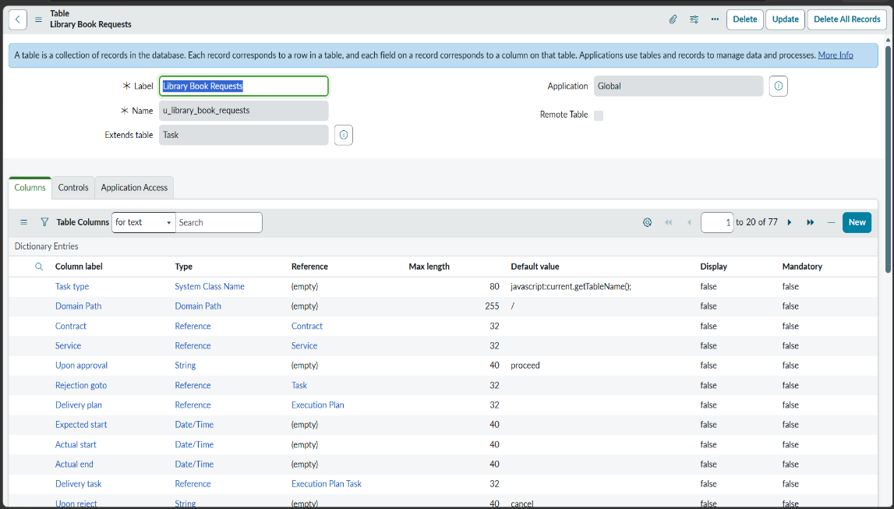

7.2 Book Request Form
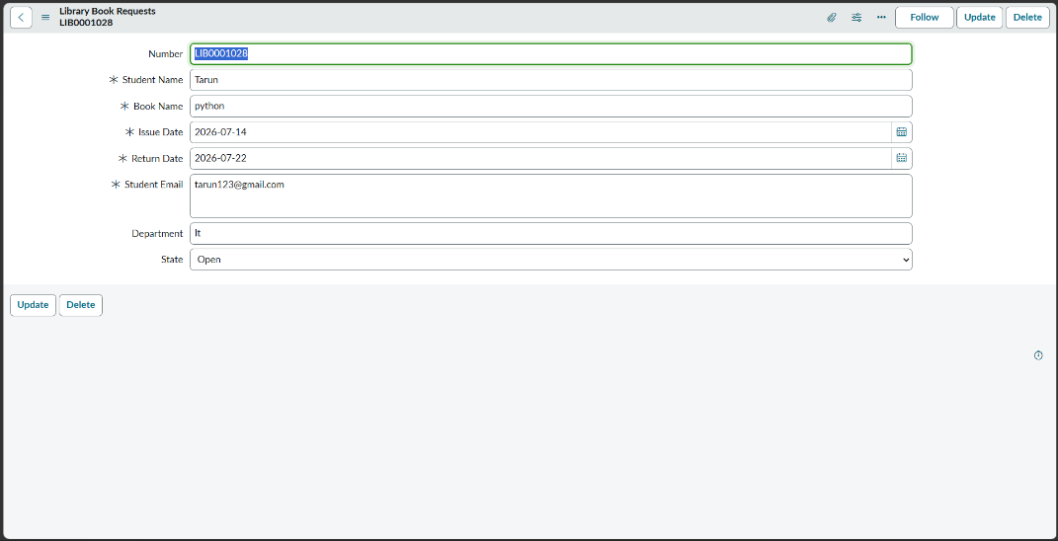

7.3 Business Rule

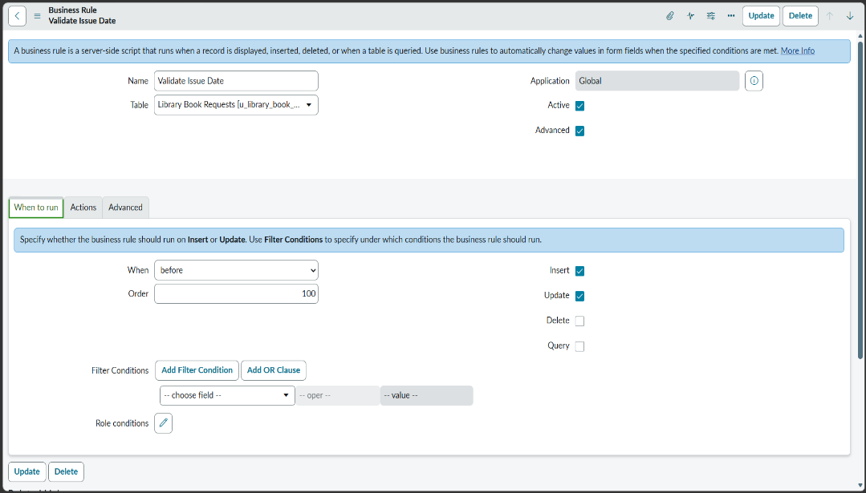

7.4 Past Date Validation

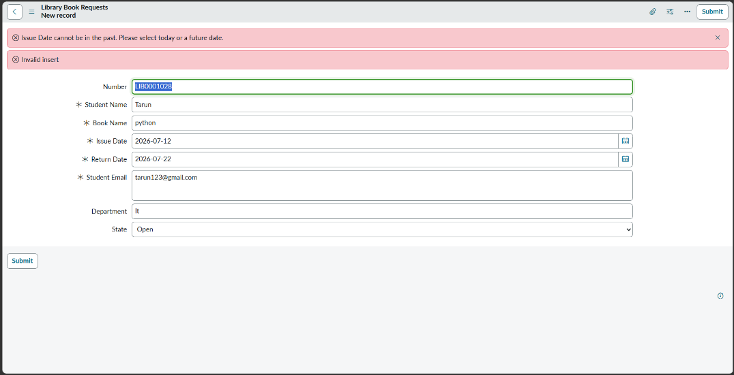

7.5 Submitted Request Record
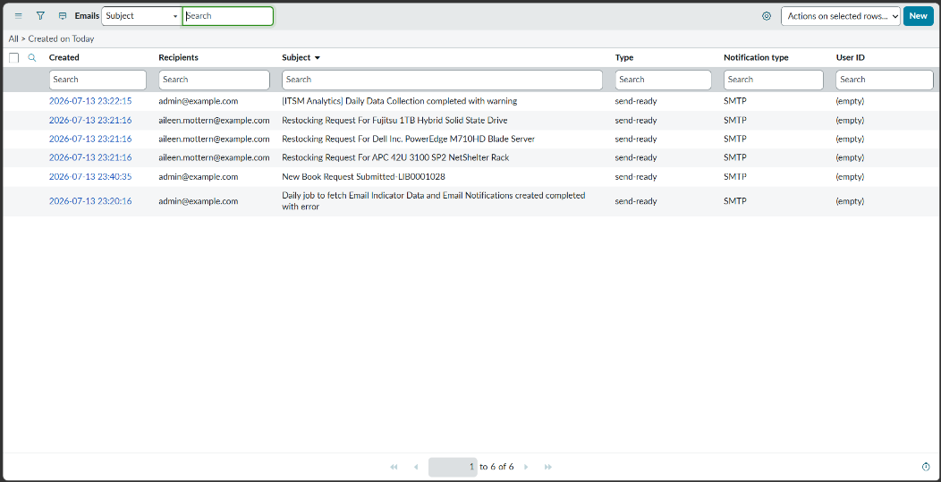

7.6 Custom Table/List View

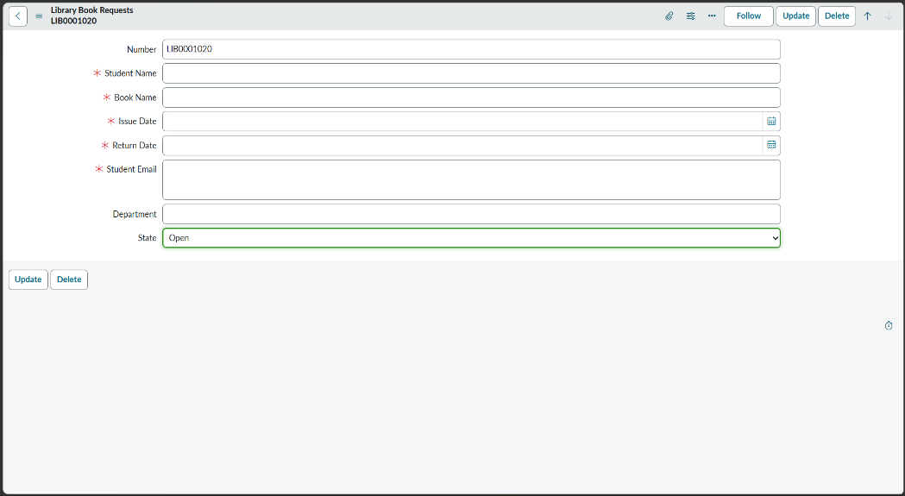

7.7 Email Notification
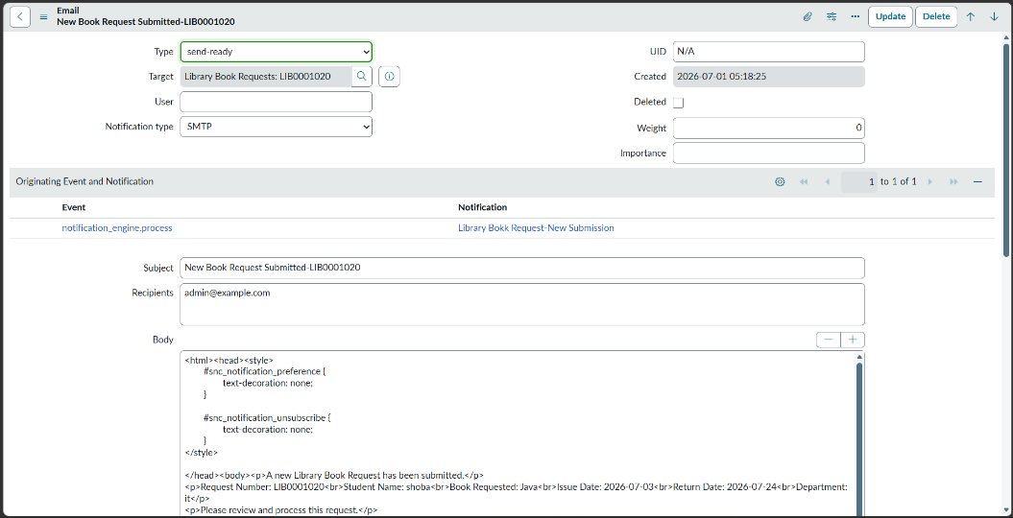

8. ADVANTAGES & DISADVANTAGES

Advantages
- Paperless process
- Faster request handling
- Automatic date validation
- Unique request number generation
- Email notification
- Secure record management

Disadvantages
- Requires internet connectivity
- Depends on the ServiceNow platform
- Limited to library request management

9. CONCLUSION
The Library Book Request Management System successfully automates the book request process using the ServiceNow platform. It validates issue dates, generates unique request numbers, stores request records securely, and automatically notifies the librarian. The system improves efficiency, accuracy, and user experience compared to the traditional manual process.

10. FUTURE SCOPE
- Book availability tracking
- Approval workflow
- SMS notifications
- Student self-service dashboard
- Fine calculation
- QR code integration
- Mobile application support

11. APPENDIX

Source Code
ServiceNow Application (Custom Table, Business Rule, Flow Designer, Notification)
Dataset Link
Not Applicable (No external dataset used)

GitHub & Project Demo Link
- GitHub Repository: https://github.com/SaiTarun-org/Library-Book-Request-System
- Project Demo Video:https://drive.google.com/file/d/1DR7TIz8LTlQRul0wSrqhwjdTvfCkVscH/view?usp=sharing

